**Filename: 2. Microservices with API gateway**

**Creating Microservices for account and loan**

**AccountController.java**

package com.example.account;

import org.springframework.web.bind.annotation.GetMapping;

import org.springframework.web.bind.annotation.PathVariable;

import org.springframework.web.bind.annotation.RestController;

*@RestController*

public class AccountController {

*@GetMapping*("/accounts/{number}")

public Account getAccountDetails(*@PathVariable* String number) {

return new Account(number, "savings", 234343);

}

class Account {

private String number;

private String type;

private double balance;

public Account(String number, String type, double balance) {

this.number = number;

this.type = type;

this.balance = balance;

}

public String getNumber() { return number; }

public String getType() { return type; }

public double getBalance() { return balance; }

}

}

**AccountApplication.java**

package com.example.account;

import org.springframework.boot.SpringApplication;

import org.springframework.boot.autoconfigure.SpringBootApplication;

@SpringBootApplication

public class AccountApplication {

public static void main(String[] args) {

SpringApplication.run(AccountApplication.class, args);

}

}

**OUTPUT:**

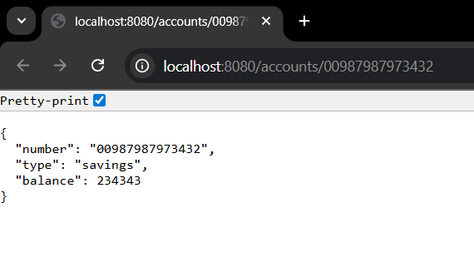

**Creating Microservices for account and loan**

**EurekaDiscoryServerApplication.java**

package com.cognizant.eureka_disovery_server;

import org.springframework.boot.SpringApplication;

import org.springframework.boot.autoconfigure.SpringBootApplication;

import org.springframework.cloud.netflix.eureka.server.EnableEurekaServer;

@SpringBootApplication

@EnableEurekaServer

public class EurekaDiscoveryServerApplication {

public static void main(String[] args) {

SpringApplication.run(EurekaDiscoveryServerApplication.class, args);

}

}  
  
**OUTPUT:**

